How to make jersey knickers with stretch lace trim
Instruction number | Tools or Machine setting | Instruction | Picture
 | Jersey Knicker pattern sheets x2 (front/back/gusset)  Spot and Cross paper  Jersey fabric, at least half a metre.  Elastic Lace – up to 1.5m | You’ll need the items to the left for this project. The other resources are listed for each step | na
Practise the skills! | Machine threaded in matching colour to jersey & set on:  Zig zag dial: 5 (means central when on A)  Stitch type: A  Stitch Length: +SS- (mid size)  Seam allowance marker: 6mm | Stitching jersey  Take a scrap of fabric any size and test your machine on this setting, so you get used to the movement of this stitch  Check it’s not missing stitches – you may need to use a jersey (ball point) needle if so  *  Cut some pieces of your jersey fabric that look like the side seams of the knickers and practise sewing them together with these settings | na
Practise the skills! | Machine threaded in matching colour to jersey & set on:  Zig zag dial: 5 (means max width)  Stitch type: D (3 step zigzag)  Stitch Length: 1.5 | Stitching elastic  Cut a length of stretch elastic 10cm long and a piece of fabric 15cm long and pin the elastic flat to one edge, overlapping by 6mm so that the jersey edge is hidden and the scalloped edge of elastic is sticking out away from the jersey. Stitch with the zig zag stitch going over the overlap, catching the jersey under the elastic. | na
1 | Original stretch Knicker Pattern sheet  Tape measure  Spot and cross paper  A sharp pencil  Paper scissors  pins | The pattern you use will be determined by how the jersey stretches on your hips:  Do this by stretching your fabric round your hips and when it’s stretched to the right tightness for knickers remove it while keeping your fingers holding each side, then measure between your fingers – note distance in cm.  Find the nearest ‘cm’ size pattern to use. Trace size pattern you are using on to new spot and cross or tracing paper – make the front and back patterns half, as will be cut on the fold, but make the gusset pattern whole by folding over the paper before cutting out  Patterns already include seam allowance 0.6cm | na
2 | Jersey fabric  Pins  Fabric Scissors | In your jersey fabric cut out 1x Front & 1X back on fold of fabric + 1 x gusset | 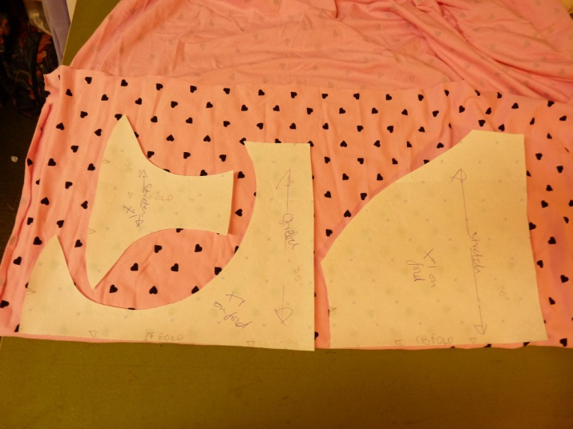
3 | Original stretch Knicker Pattern sheet  Tape measure  Fabric Scissors | Also cut 2x leg elastic and 1x waist elastic to the correct length as stated on the original pattern sheet  The lengths stated already inc seam allowance 1cm each end. When you’ve cut the elastic, try the bits in a loop round your hip and leg to check they are not too big. Cut a bit smaller if they are.
4 | Cut jersey pieces  pins | Lay pieces on the table:  Front right side up, longest edge away from you  Back wrong side up, longest edge away from you  Gusset wrong side up, widest edge toward you  Then pin all 3 pieces together along the widest edge of the gusset | 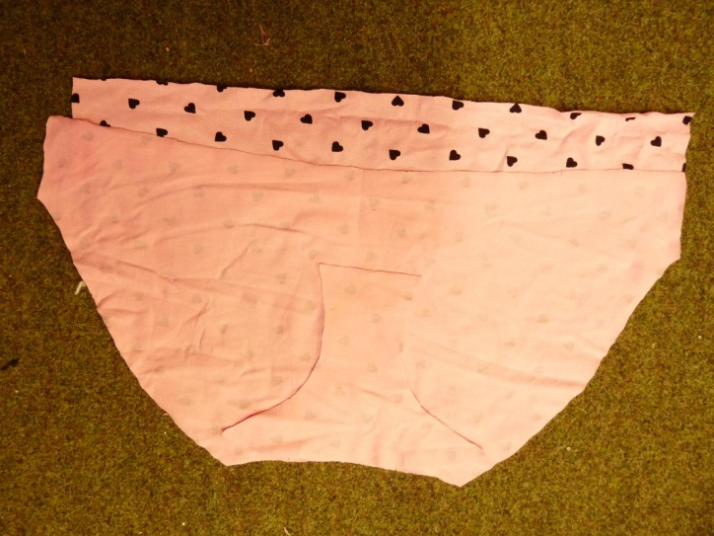
5 | Machine threaded in matching colour to jersey & set on:  Zig zag dial: 5 (means central when on A)  Stitch type: A  Stitch Length: +SS- (mid size)  Seam allowance marker: 6mm | Stitch the seam, backstitching each end with the settings shown to left.  Important: hold onto the threads as you start, and giving a little tug if it looks like the fabric is getting stuck/disappearing down the bobbin thread hole | 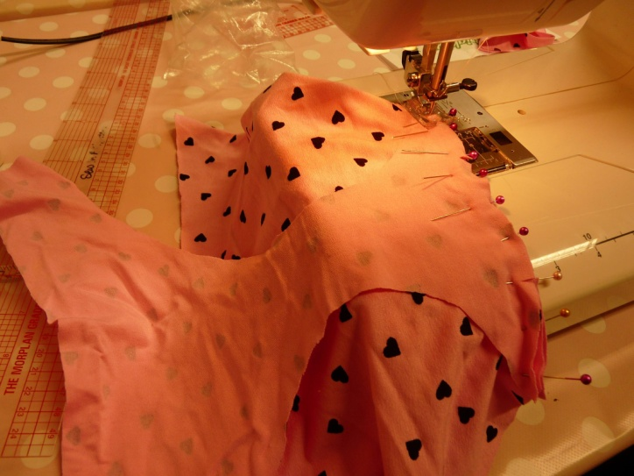
6 | Iron & board – check temperature first on a scrap of your fabric  Machine setting as last instruction  Seam allowance marker: 6mm | Press gusset towards front piece and pin sides of gusset to knickers  Stitch the gusset edges to the knickers, wrong sides together as you pressed them, backstitching each end  Important: hold onto the threads at start as in previous instruction | 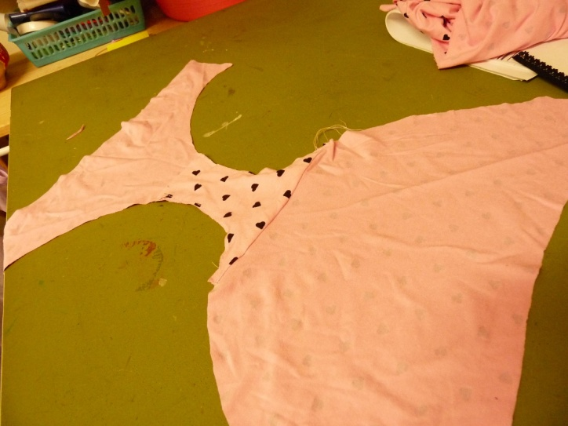
7 | Pins  Machine setting as last instruction  Iron & board – temperature as before | Pin side seams, right sides together & stitch  . Important: hold onto the threads at start as in previous instruction  Press side seams seam allowance apart | 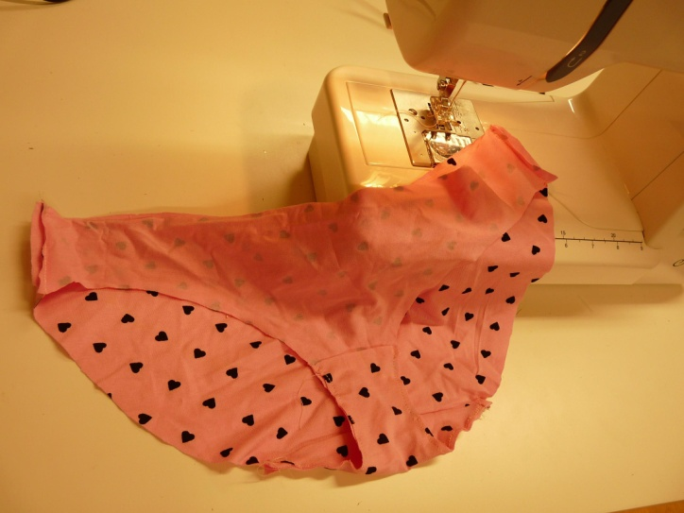
8 | Cut elastic pieces  Machine setting as last instruction but with 1cm seam allowance marked instead of 6mm | Fold one elastic piece in half, right sides together and stitch the ends together with a 1cm seam allowance  Important: hold onto the threads at start as in previous instruction  Repeat with all 3 pieces of elastic | 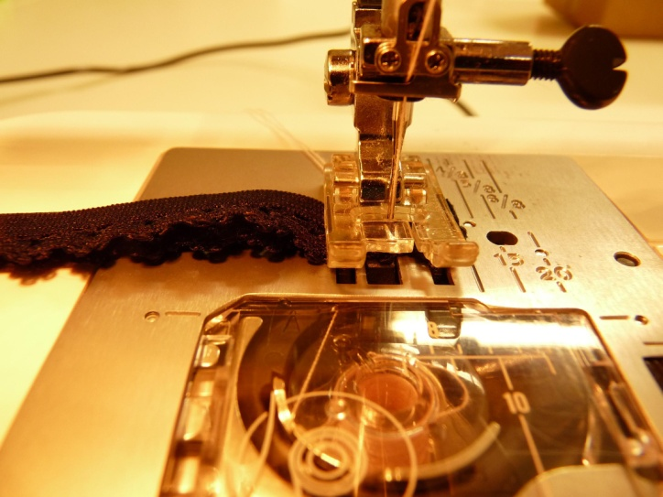
9 | Pins | Mark quarter measurements on the elastic with pins:  Fold one piece of elastic in half with the seam at one fold. Stick a pin in directly opposite the seam, then fold again so this pinned point meets the seam and pin the mid-way points.  Repeat for the other bits of elastic | 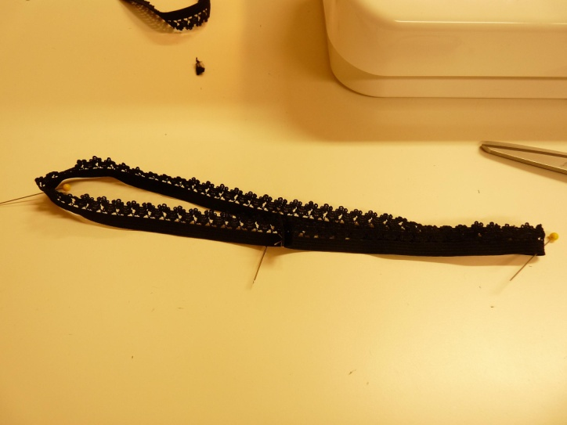
10 | Pins | Do the same on the knickers you’ve made – it’s a bit trickier as they are not straight edges, but easing the edges together without stretching the cloth, find the quarter marks on the leg holes and waist using the same method as for elastic | 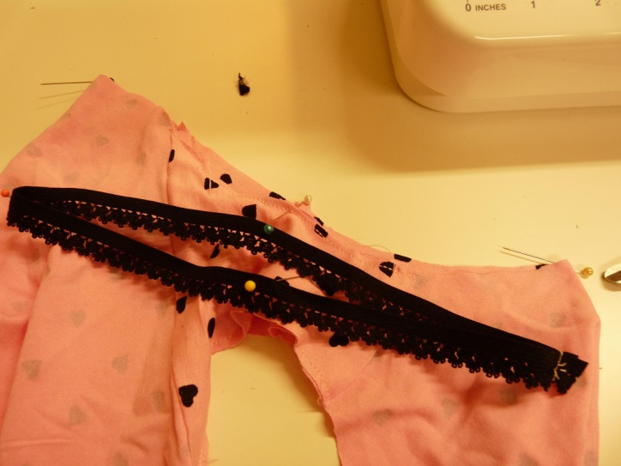
11 | Pins  Tape measure | Now pin the elastic for one leg to the leg hole:  Decide where you want the join – at the side seam or at the crotch? Pin elastic to knickers matching all 4 pins first (pins horizontal, with heads of pins pointing toward you with the main knicker fabric to your left, this way it will be easy to pull out the pins as you sew) , pin so that you are laying the wrong side of the elastic, scalloped edge away from the knickers, on top of the right side edge of the knickers, with an overlap of 6mm, hiding the raw edge of the jersey behind the lace, but overlapping enough so that you can zig zag them together and catch the jersey properly. | 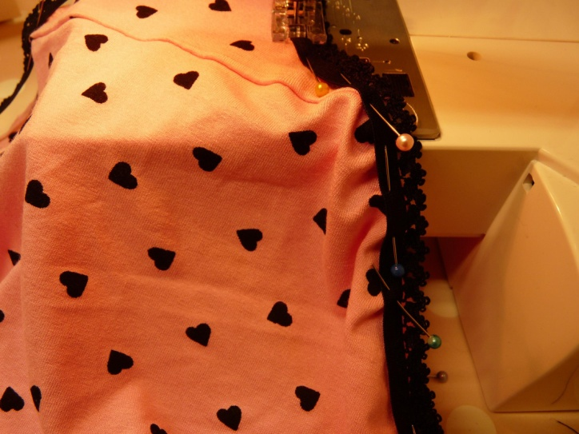
12 | Pins | Once the 4 points are pinned stretch the fabric in between the pins and pin again so you have 8-12 pins around the leg hole. The elastic will be stretched onto the knickers, as it is smaller than the knickers.
13 | Pins  Somewhere private to try them on and a mirror! | Repeat instructions 12 and 13 for the other leg hole and the waist.  Then carefully try them on for size, just in case you need to adjust the size of knickers or elastic.
14 | Machine threaded in matching colour to jersey & set on:  Zig zag dial: 5 (widest zig zag setting)  Stitch type: D  Stitch Length: 1.5  Take the sleeve off the machine so you can sew in a circle | Stitch the elastic to knickers, stretching out so no tucks in the jersey. Overlap beginning and end of stitching instead of zig zagging | 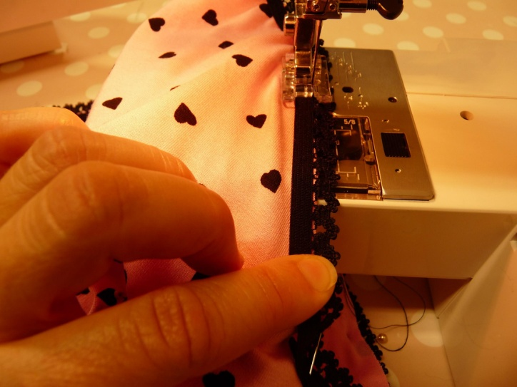
15 | As above | Stitch both leg holes and the waist, trim threads and you are done!  You could decorate with ribbons, bows or mini roses… | 